**Implementing Web Application**

**Create UI Interact with Application**

|  |  |
| --- | --- |
| Date | 25 November 2022 |
| Team ID | PNT2022TMID11590 |
| Project Name | CONTAINMENT ZONE ALERTING APPLICATION |

**UI Interact with Application:**

**Admin App:**

Login Page:

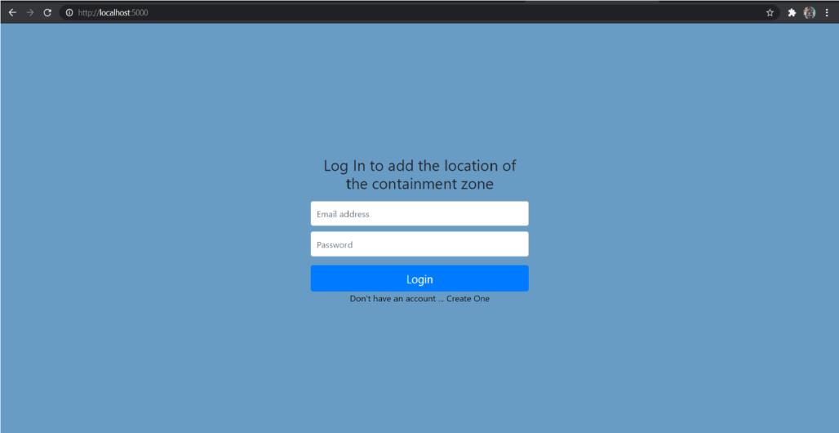

Register page:

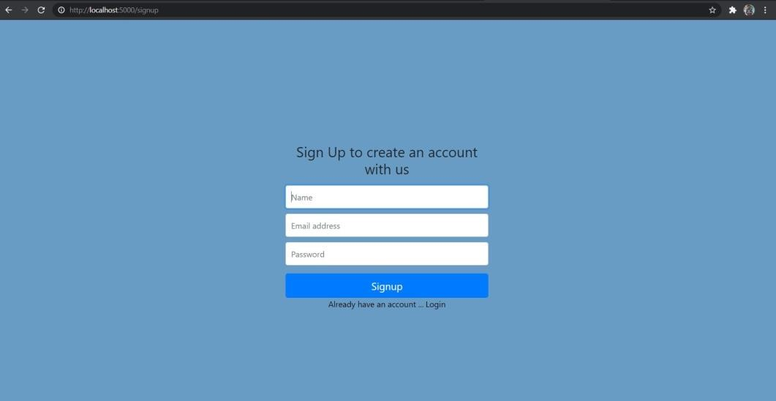

Home page:

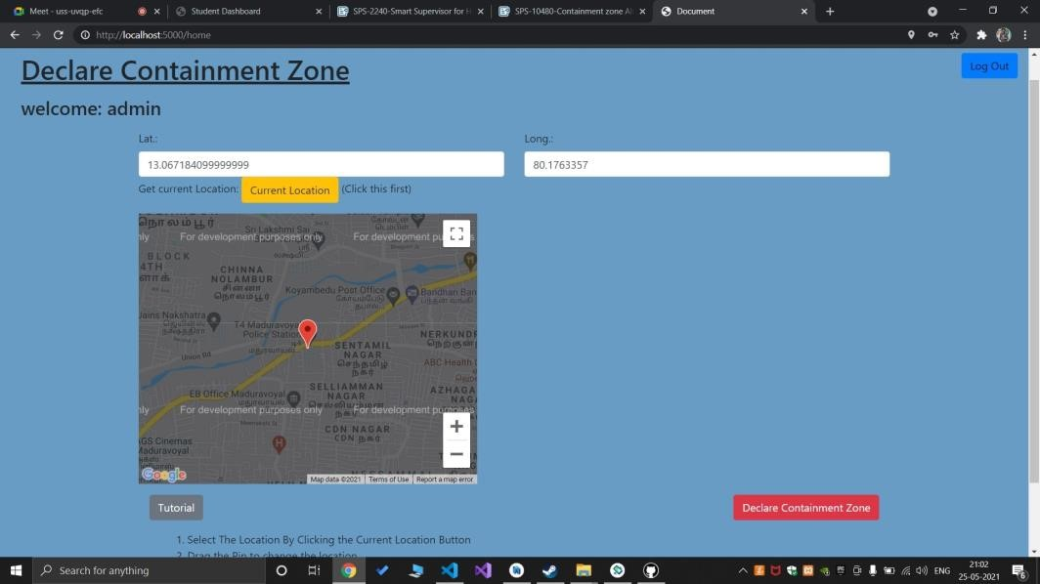

Location data page:

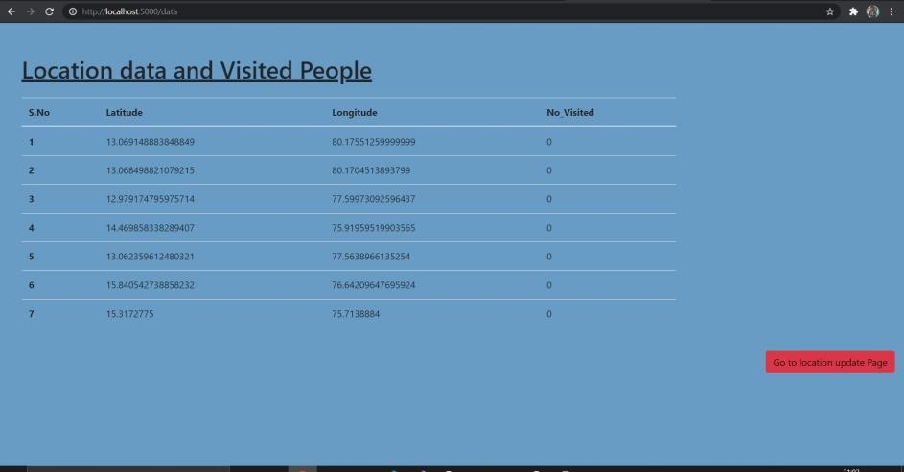

Client Application:

Register screen:

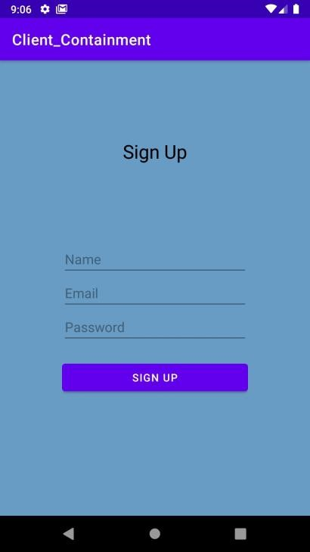

Current Location:

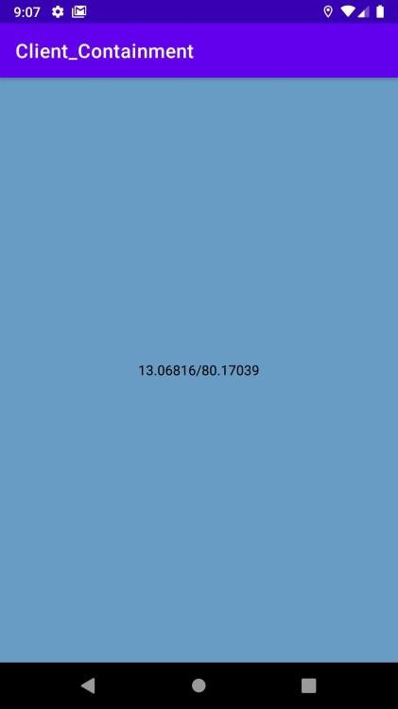

An Email will be sent to the registered mail id if the location is within 100 meters of the locations present in the admin app.

